Problem
The layer defined in geoserver
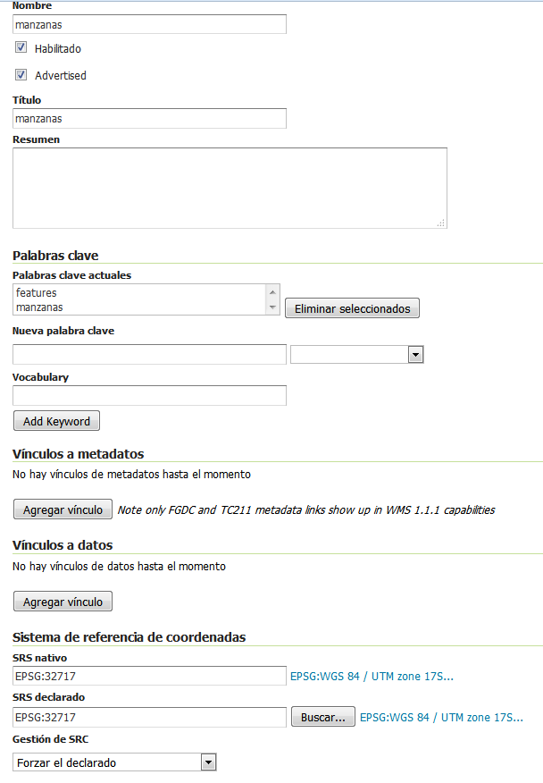
Viewed in Qgis 2.14 – have a displacement of 33 m aprox

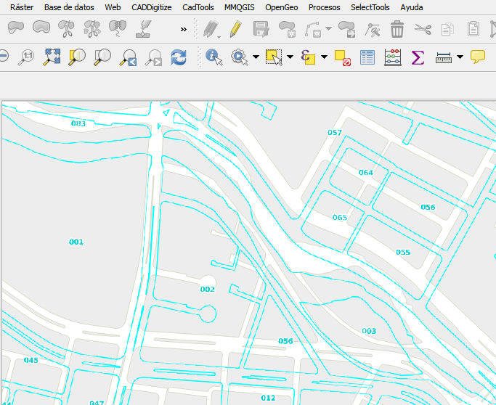

Properties of layer

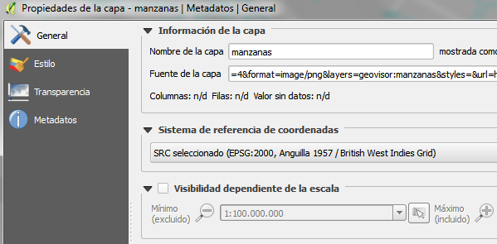

EPSG:2000 why?????

COMMENTS

Only in Qgis 2.8.1 works fine.
In any other sw gis can view ok

