Two layers, wms and postgis

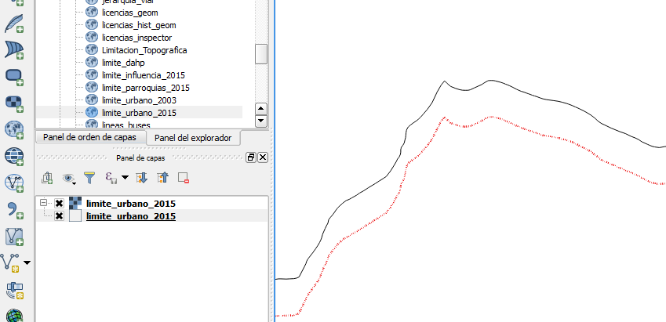
do not match the boundaries

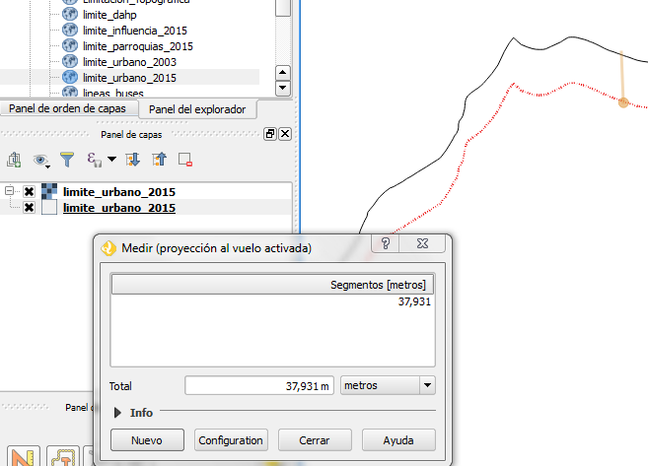
Qgis change de SRS from EPSG:32717 to EPSG:2000, Anguilla 1957 ?????
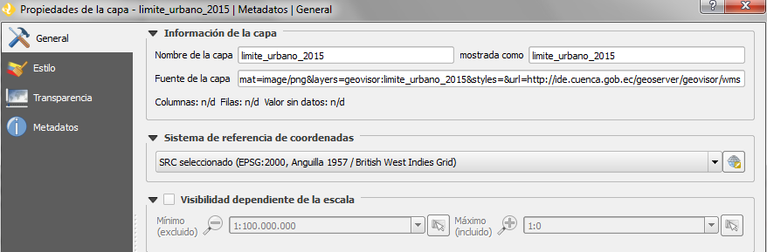

Thanks for your help

