Geodata / shp-file
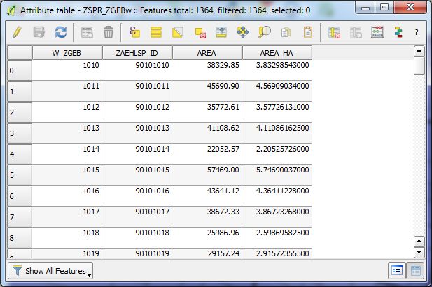

dBASE – Table / ID & categorial variables
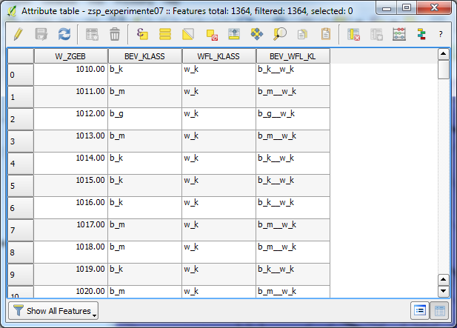

Join – dialogue
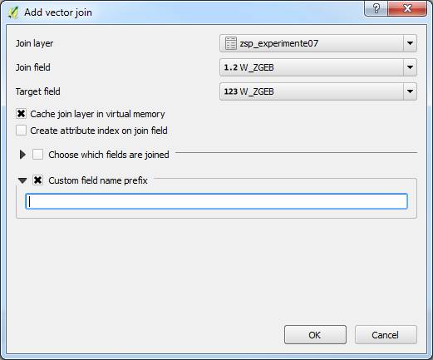
… resulting table (including joined fields)
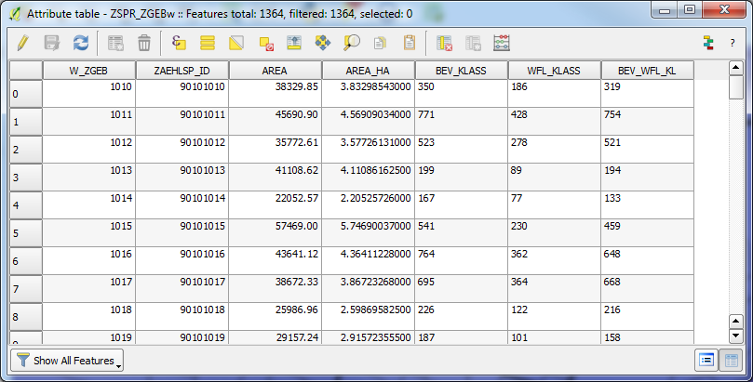

Style / categorized … based on the „BEV_KLASS“-field of this attibute table
(including feature count information in Layers Panel)
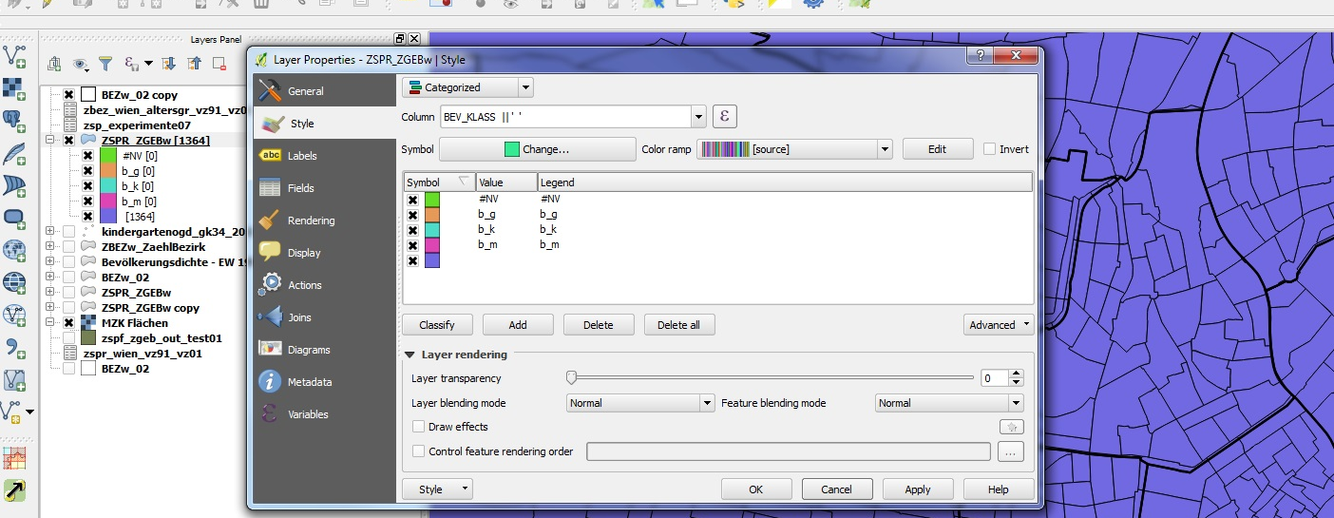

field calculation in dBASE-table
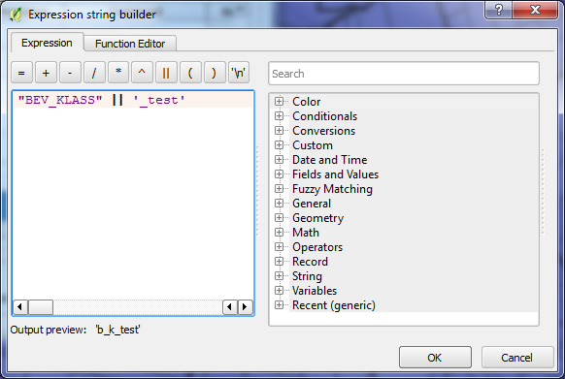

resulting dBASE-table
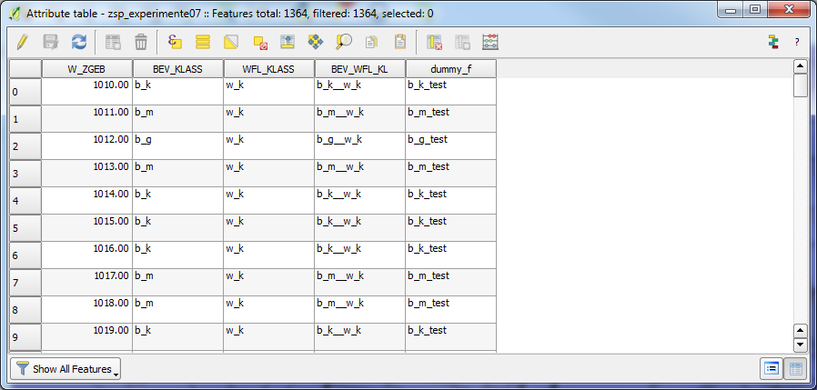
resulting (updated) attribute table …
